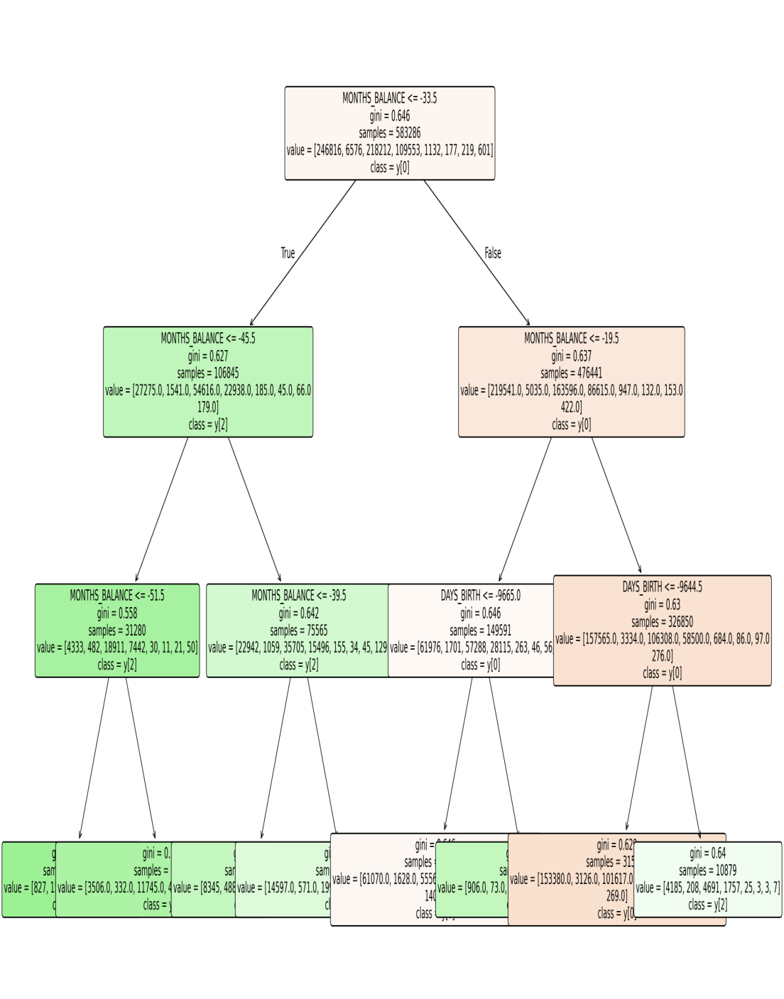

Decision Tree Model Report
Rows: 777715, Columns: 20
Target: STATUS
Decision Tree Accuracy: 0.862
Categorical columns were label-encoded. Data split: 80/20.

